***POLO PANT303***

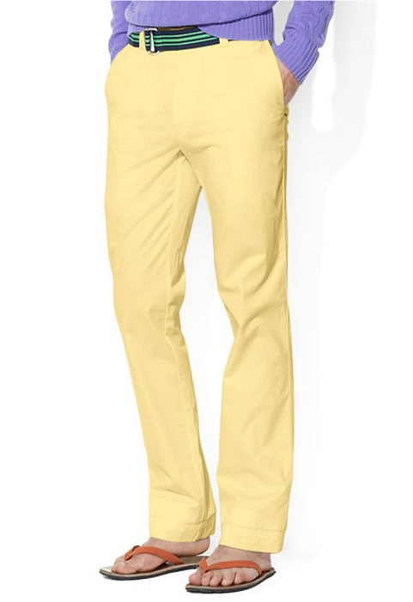

***DESCRIPTION:***

**POLO’S PANTS MOST VALUABLE AND BEST SELLING PRODUCT ALL OVER THE WORLD.THEY ARE LOTS OF VARIOUS COLOR AVAILABLE IN MARKETS.IT WAS AVAILABLE IN NARROW AND JEANS PANTS.IT HAS VERY SOFT.THEY ARE AVAILABLE IN EVERY SIZE.**